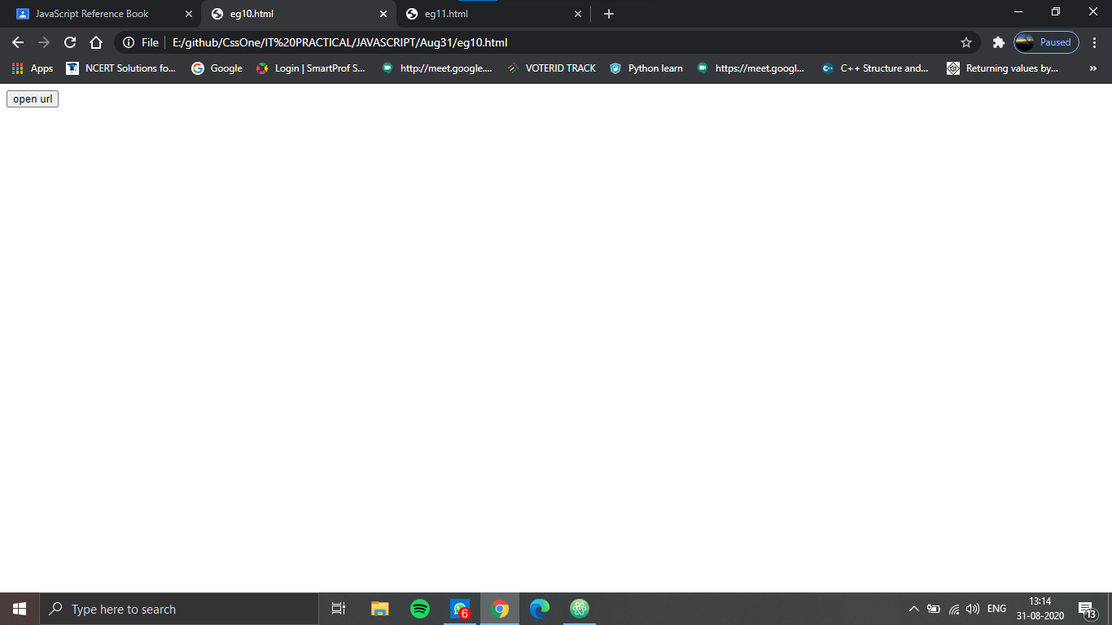

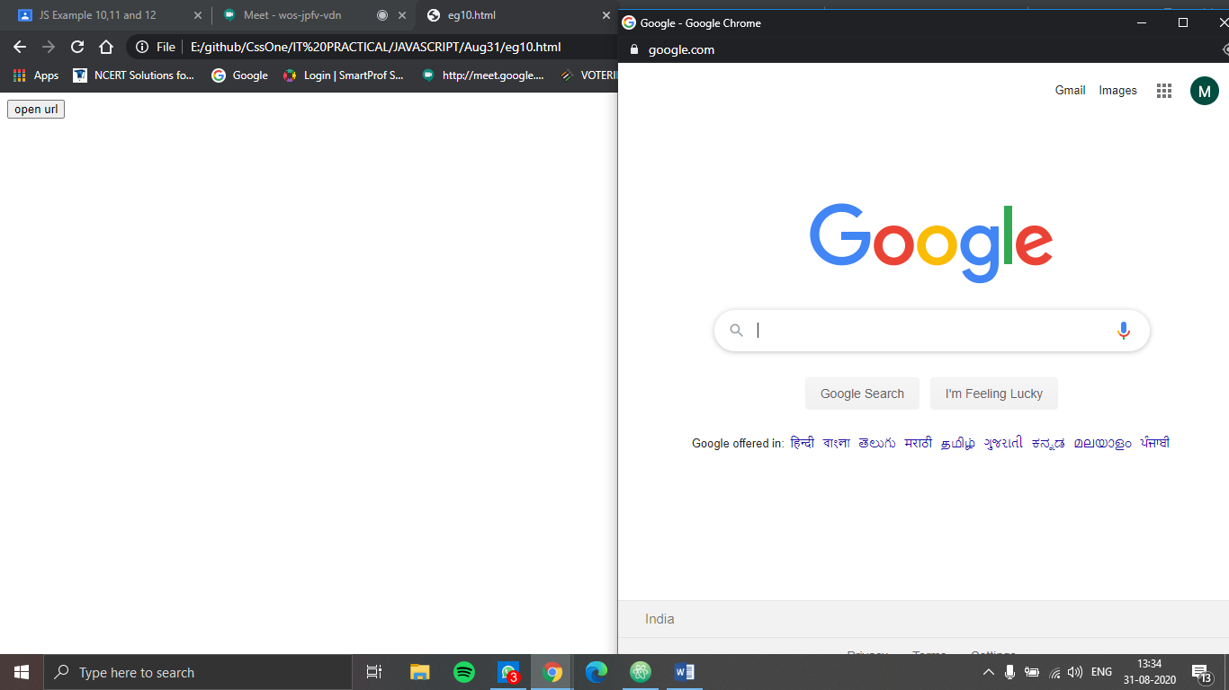

<!DOCTYPE html>

<html>

<head>

<script type="text/javascript">

function makenewwindow(){

var newwindow = prompt("enter the document to go to in format http://www.url.com","");

if (!(newwindow ==null|| newwindow =="")) {

window.open(newwindow,"", "status,menubar=yes,resizable =no, toolbar=no")

}

else

{

var blankwindow = window.open("","","status,menubar=yes,resizable=no,toolbar=no");

var windowcontent="<html><body style=background-color=FFFFFF><H1>new window</H1>"

windowcontent+="<FORM><INPUT type=button Name=close onClick= window.close() value=close></FORM></BODY></HTML>"

blankwindow.document.write(windowcontent)

}

}

</script>

</head>

<body>

<FORM>

<input name="open" onclick="makenewwindow()" type="button" value="open url">

</FORM>

</body>

</html>

